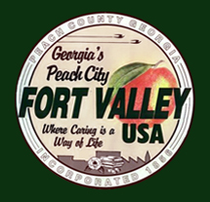

**Official List of Qualifying Candidates**

1. Andrew Kim - Mayor
2. Shakeena Reeves - Mayor
3. Jefferey Lundy - Mayor
4. Anthony Clark - Mayor
5. Marcus Agostino – City Council West Ward
6. Juanita Plant Bryant – City Council East Ward
7. Carson L. Brooks Jr. - City Council East Ward
8. Alton Howard – City Council At Large
9. Ralph L. Davis II – City Council At Large
10. Talisha Carter-Moody - City Council At Large
11. Keytrick Jones – Utility Commissioner Eastward
12. Alre Horton – Utility Commissioner Post 3 At Large
13. Sheniqua Freeman, City Council – East Ward
14. Donald J. Williams, City Council – West Ward